Add Sequences
This is an instruction about how to add audeme sequences and a step by step example of adding two sequences (“PAST/HISTORY” and “OUTERSPACE”) into the game.

1. Formatting sequence
Format sequence like this: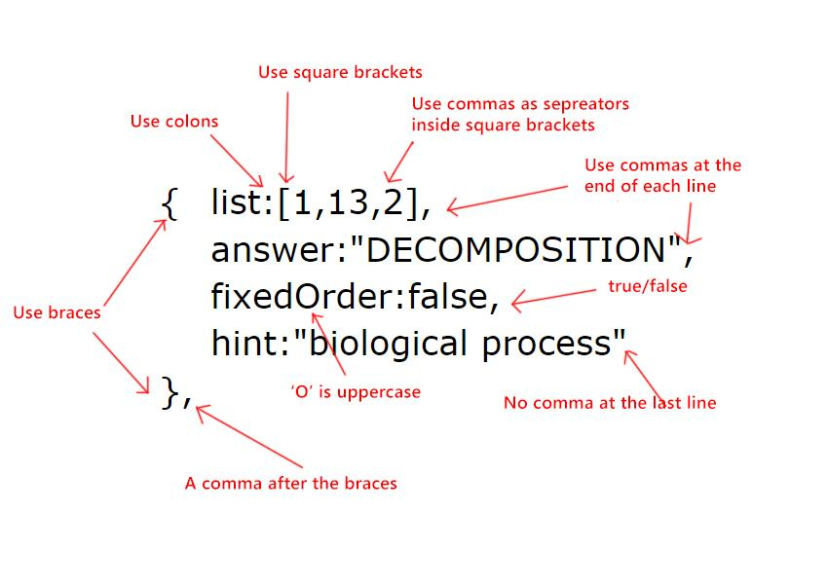
Mapping

"air"------->0
"animal"------->1
"earth"------->2

"rising"------->3
"inside"------->4
"lowering"------->5

"fire"------->6
"machine"------->7
"water"------->8

"big"------->9
"cold"------->10
"small"------->11

"fast"------->12
"process"------->13
"slow"------->14

"people"------->15
"outside"------->16
"time"------->17

Example: Formatting “PAST/HISTORY” and “OUTER SPACE”.

{ list:[17,5],
answer:"PAST/HISTORY",
fixedOrder:false,
hint:"time period"
},

{ list:[16,9,9,9,0],
answer:"OUTER SPACE",
fixedOrder:true,
hint:"astronomy"
},

2. Paste the code into game files.

Example: Adding “PAST/HISTORY” and “OUTER SPACE”.
Open “sequences.js” in the folder using any text editor (Notepad is used in the example).

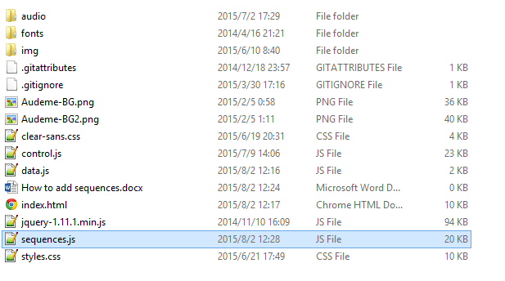
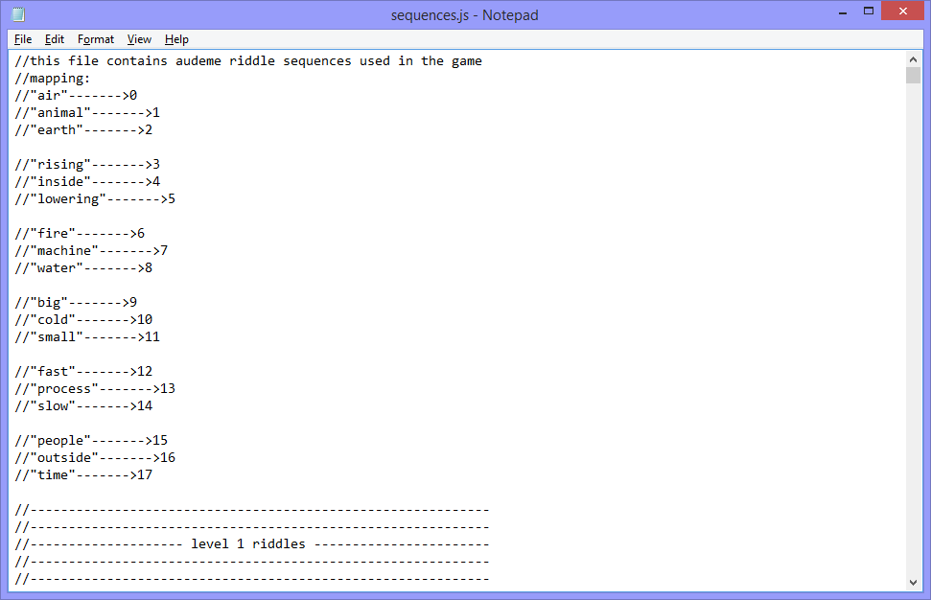

The sequences are categorized by their difficulty level (1,2,3, and 4). Use text editor’s search function to locate where the code should be pasted.

Both “PAST/HISTORY” and “OUTERSPACE” are level 4 sequences. Search “level 4”
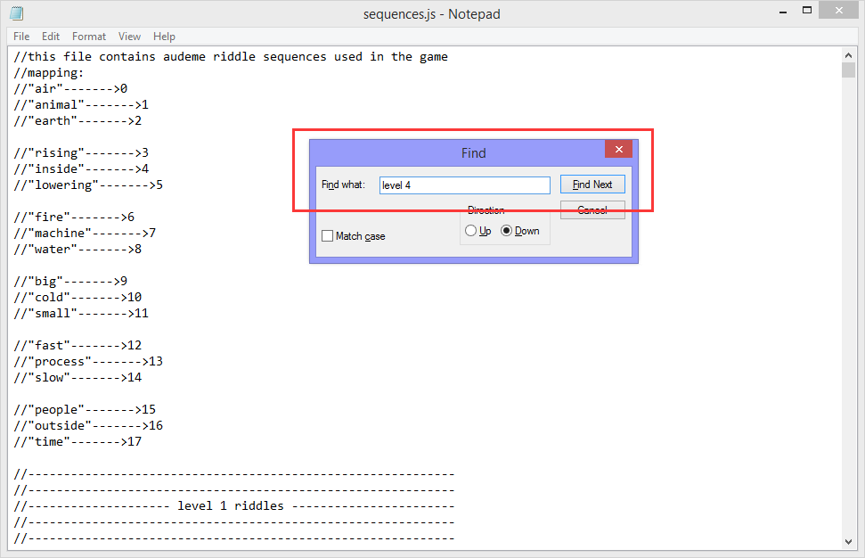
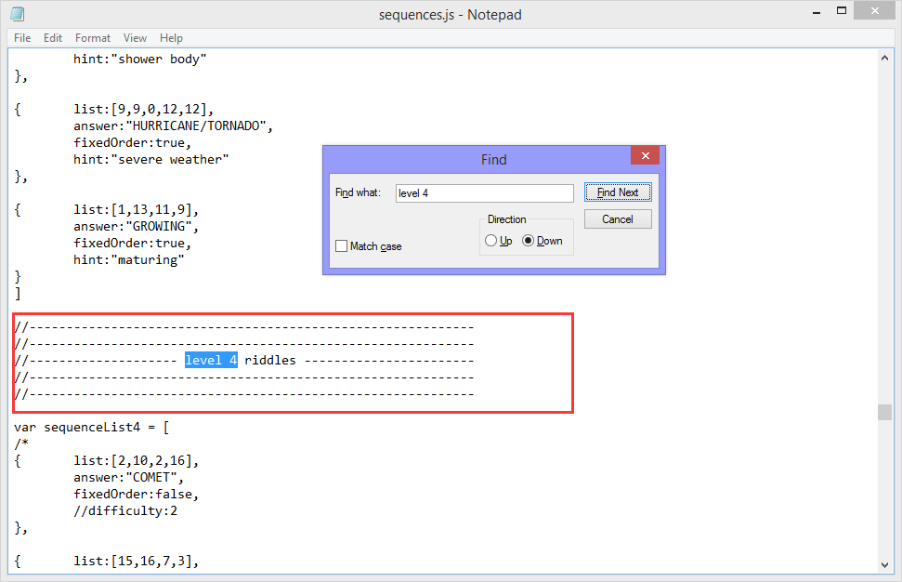

Paste code snippets right after the square bracket.

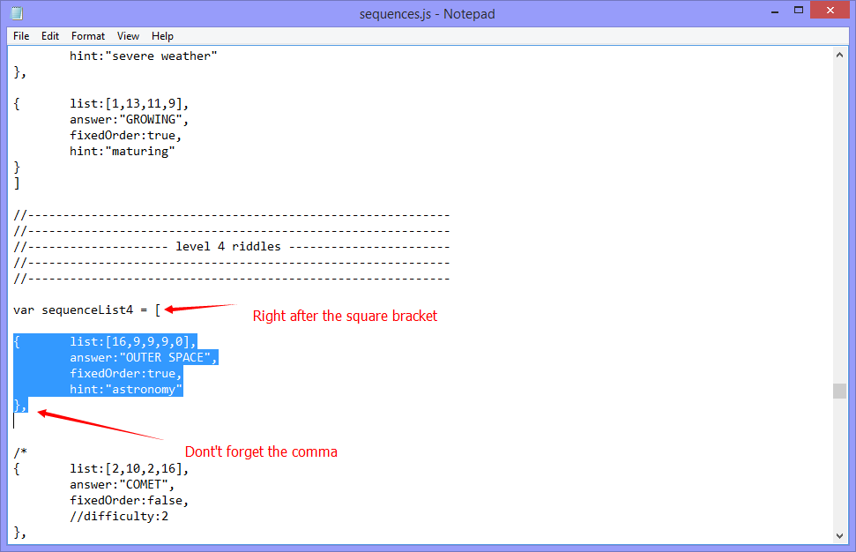

Save the file and refresh the game page.

You can open list.html to check if the sequences were added correctly.
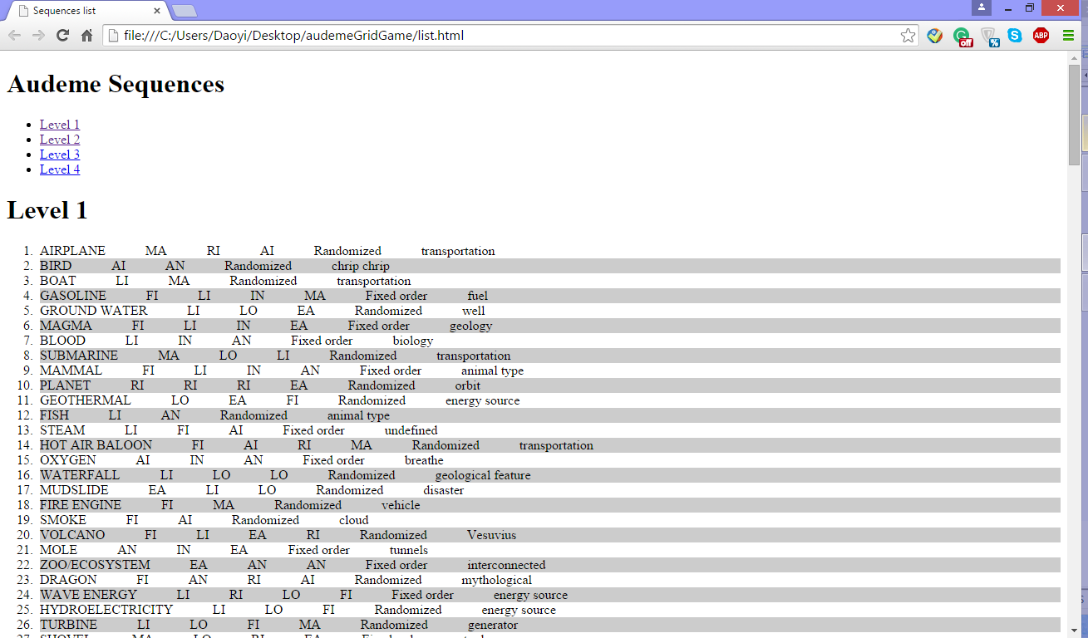

Modify/Delete Existing Sequences
Use text editor’s search function to locate the corresponding code.

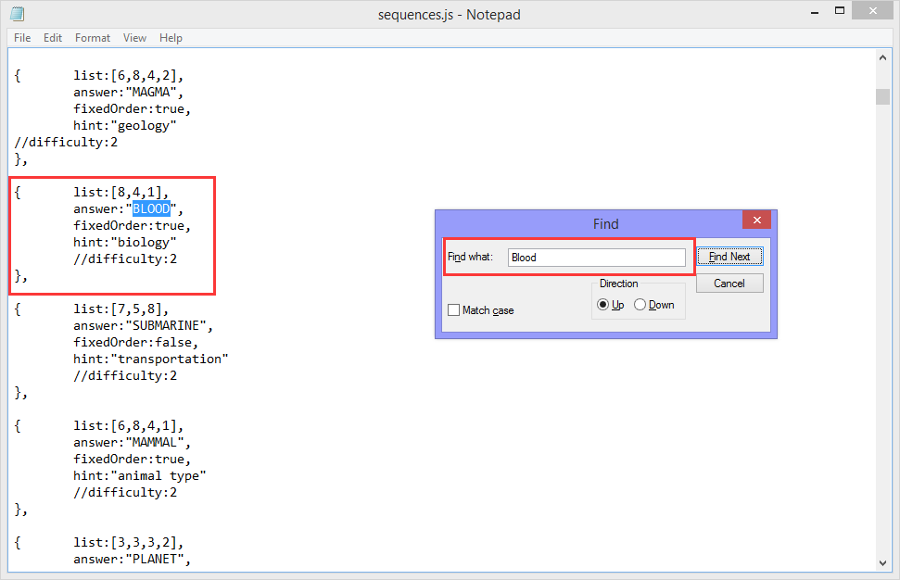

Make changes and save the file. Refresh the game page. If you want to delete this sequence, make sure to delete the last comma as well.

JavaScript object
The sequences are stored as JavaScript objects. Check here for more information about the syntax: http://www.w3schools.com/js/js_objects.asp

